Created a file Max-temp.txt in the local FS and added data to it.

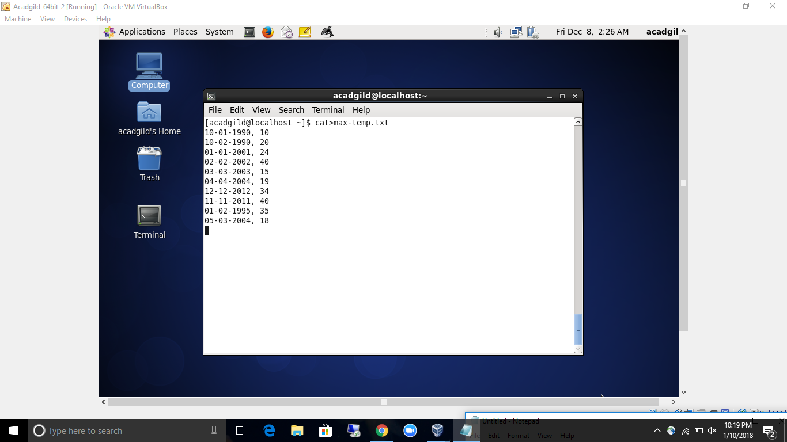

moved the file from local fs to the directory

